Ethics Training for Public Employees

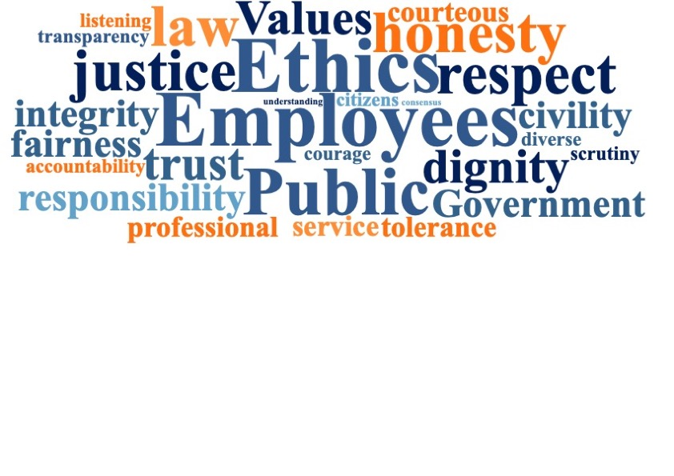

Certificate of Completion

This certificate is proudly presented to:
Enter students name

For completion of Ethics Training for Public Employees on:
ENTER DATE
Signed by: _______________________________

SEAC
Bringing Ethics Awareness and Training to our Communities
Visit us online at www.sharedethics.com

