Join us…
Ethics Training
for Public Employees

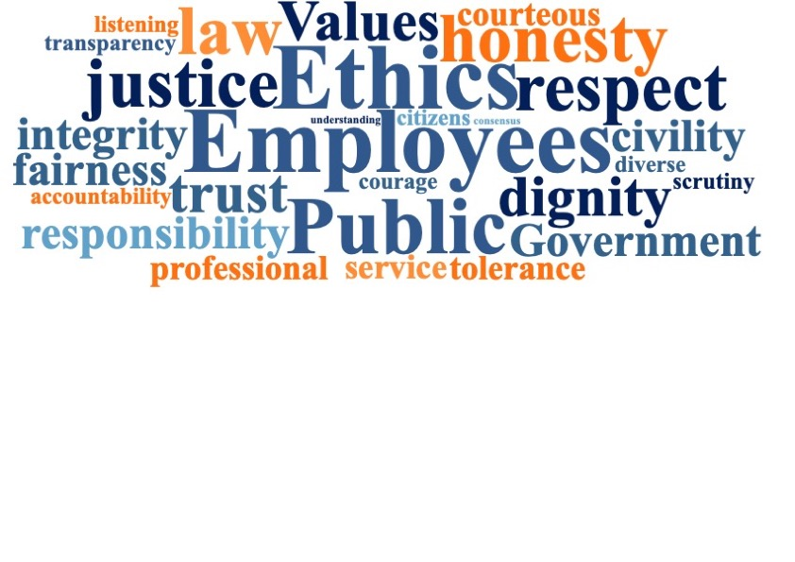

WHEN  day, date, time | WHERE  Location

Our community, as a member of SEAC (Shared Ethics Advisory Commission), has voluntarily resolved to adopt the Code of Shared Ethics and Values. This Ethics Training will introduce you to that Code and address potential ethical issues that you may encounter.

SEAC
Bringing Ethics Awareness and Training to our Communities
Visit us online at www.sharedethics.com

